BRAINSTORMING PHASE
Date | 31 January 2025
Team ID | LTVIP2026TMIDS73798
Project Name | Online Payments Fraud Detection Using Machine Learning

1.1 Problem Statement
With the rapid growth of online payment platforms, fraudulent transactions have increased significantly. Financial institutions face major challenges in detecting fraudulent activities in real time while minimizing false positives.
Traditional rule-based systems are not efficient in identifying complex fraud patterns. Therefore, there is a need for an intelligent system that can automatically analyze transaction details and classify transactions as fraudulent or legitimate.
Problem Definition:
To develop a Machine Learning-based Online Payments Fraud Detection System that accurately identifies fraudulent transactions using historical transaction data and provides real-time prediction through a web interface.

1.2 Expected Output
The system should:
- Accept transaction details as input from the user.
- Process and encode the input data.
- Predict whether the transaction is:
  - Fraudulent
  - Legitimate
- Display:
  - Fraud probability score
  - Risk level classification (Low / Medium / High)
Final Output Example
Transaction Details | Output
Normal payment | Legitimate (Low Risk)
Large abnormal transfer | Fraudulent (High Risk)

Enter the transaction details.
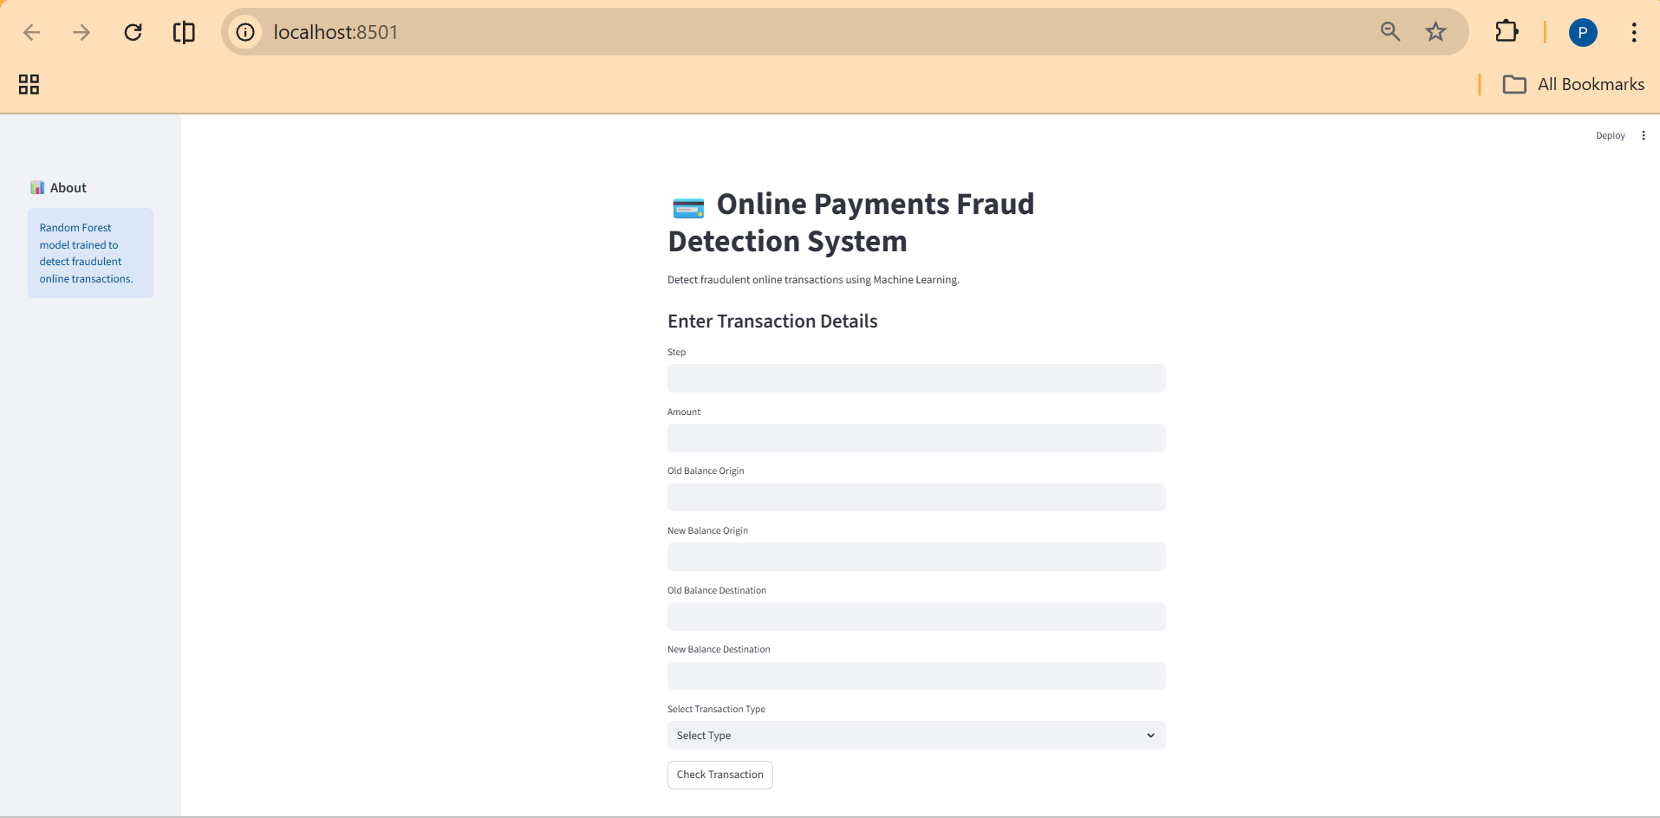
Click on the check transaction button to predict your transaction.
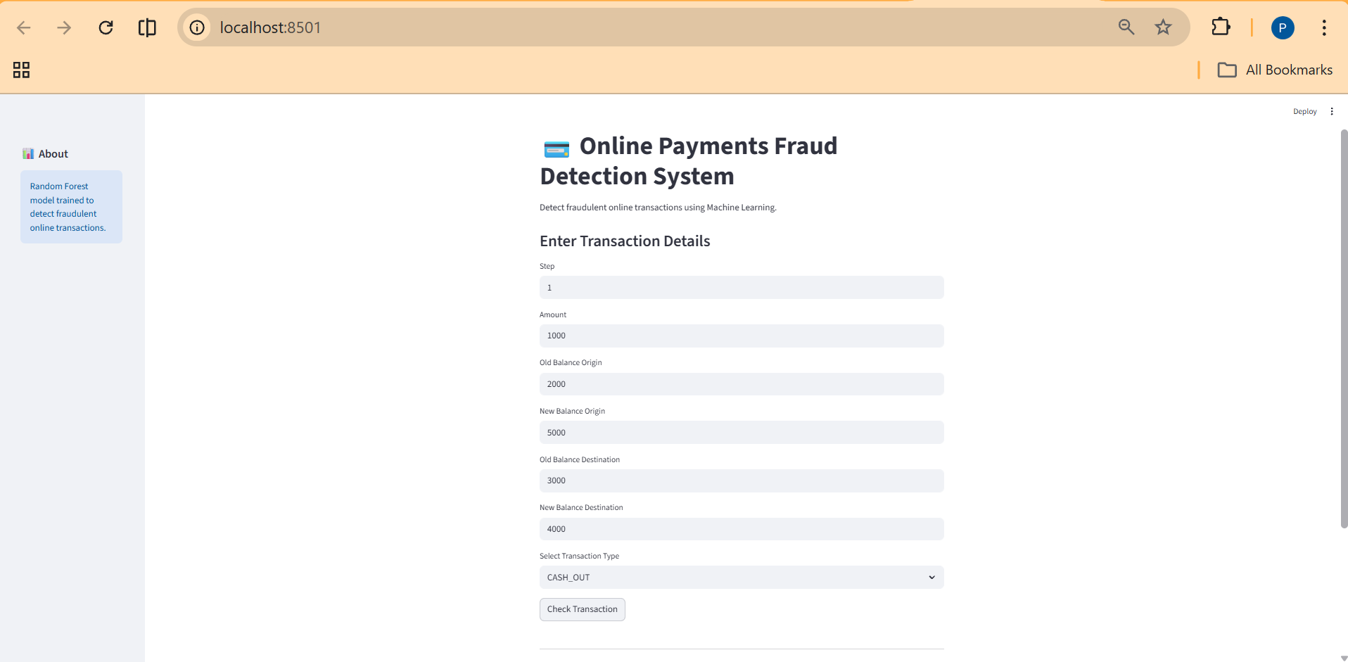

The output is displayed whether the transaction is fraud or not fraud.
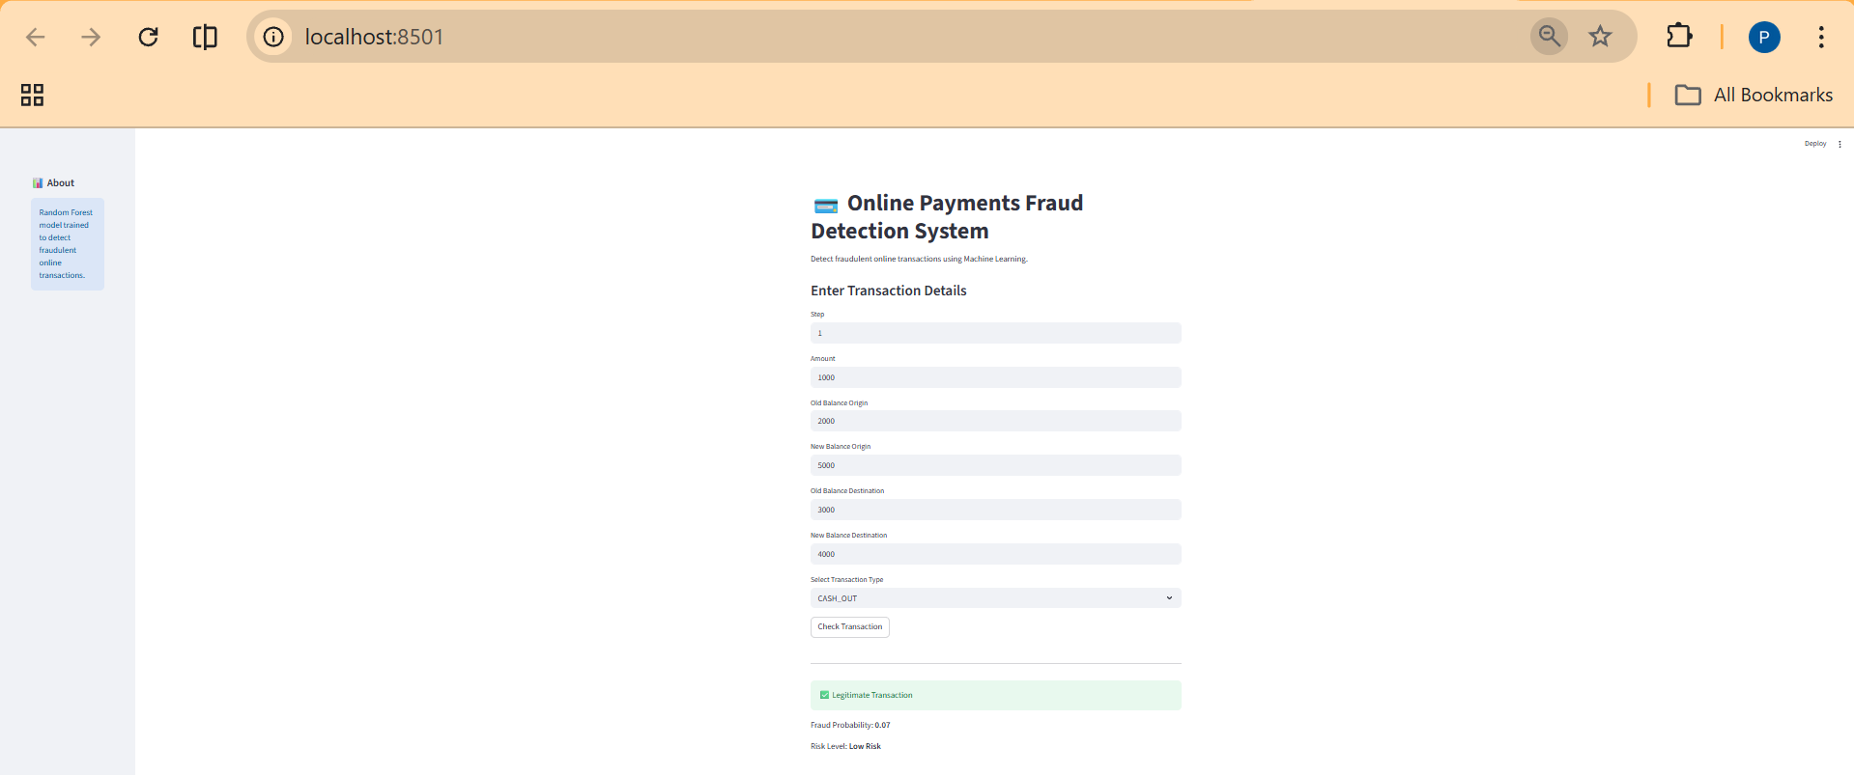

1.3 Technologies Used
The following technologies are used in the project:
Programming Language
- Python
Libraries
- Pandas (Data preprocessing)
- NumPy (Numerical computations)
- Scikit-learn (Machine Learning algorithms)
- Joblib (Model saving and loading)
- Streamlit (Web application interface)
Tools
- Jupyter Notebook (Model training)
- VS Code (Development environment)

1.4 Frameworks Used
1. Machine Learning Framework
- Scikit-learn
  - Used for implementing the Random Forest classifier
  - Used for training, testing, and evaluation
2. Web Application Framework
- Streamlit
  - Used to build an interactive web interface
  - Handles user input and displays prediction results

1.5 Selected Algorithm
The selected algorithm for fraud detection is:
Random Forest Classifier
Reasons for Selection:
- High classification accuracy
- Reduces overfitting
- Works well with structured financial data
- Handles multiple features efficiently

